ExNo:7 //FIRST FORM

PROGRAM:

<html>

<head>

<meta http-equiv="Content-Type" content="text/html; charset=UTF-8">

<title></title>

</head>

<center>

<body>

<form action="welcome.php" method="post">

Name: <input type="text" name="name"><br><br>

E-mail: <input type="text" name="email"><br><br>

<input type="submit">

</form>

</center>

<?php

// put your code here

?>

</body>

</html>

//WELCOME FORM

PROGRAM:

<html>

<head>

<meta http-equiv="Content-Type" content="text/html; charset=UTF-8">

<title></title>

</head>

<body>

Welcome <br><br>

Your user name is: <?php echo $_POST["name"]; ?><br>

Your email address is: <?php echo $_POST["email"]; ?>

</body>

</html>

OUTPUT:

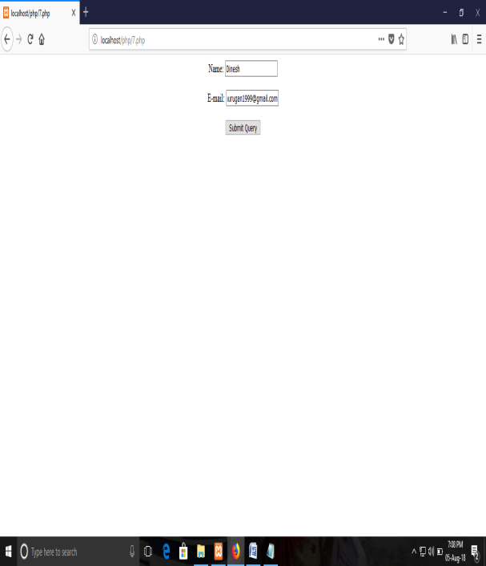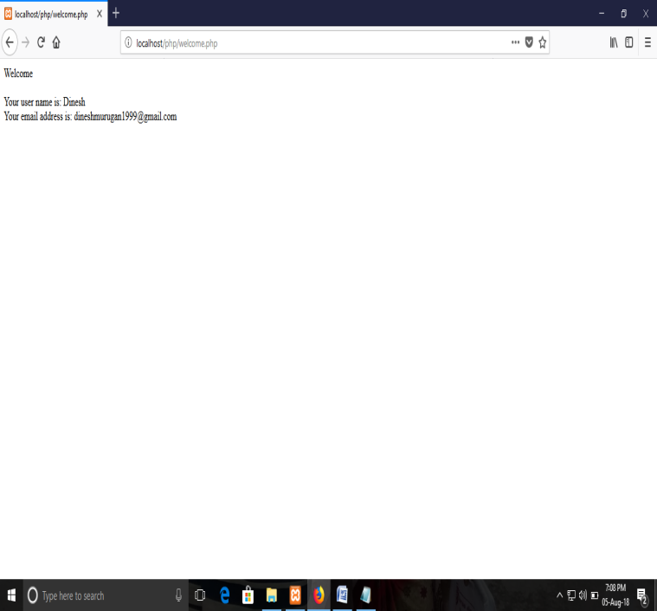

ExNo:8 //FIRST FORM

PROGRAM:

<html>

<head>

<meta http-equiv="Content-Type" content="text/html; charset=UTF-8">

<title></title>

</head>

<body>

<center>

<h1>A small example page to insert some data in to the MySQL database using PHP</h1>

<form action="insert.php" method="post">

Firstname: <input type="text" name="fname" /><br><br>

Lastname: <input type="text" name="lname" /><br><br>

<input type="submit" />

</form>

</center>

<?php

// put your code here

?>

</body>

</html>

//INSERT FORM

PROGRAM:

<html>

<head>

<meta http-equiv="Content-Type" content="text/html; charset=UTF-8">

<title></title>

</head>

<body>

<?php

// put your code here

$servername = "localhost";

$username = "root";

$password = "";

$dbname = "nametable";

$conn = new mysqli($servername, $username, $password, $dbname);

// Check connection

if ($conn->connect_error) {

die("Connection failed: " . $conn->connect_error);

}

$sql = "INSERT INTO nametable (firstname, lastname)

VALUES ('$_POST[fname]','$_POST[lname]')";

if (mysqli_query($conn, $sql)) {

echo "New record created successfully";

}

else

{

echo "Error: " . $sql . "<br>" . mysqli_error($conn);

}

mysqli_close($conn);

?>

</body>

</html>

OUTPUT:

